Inspired Local Competition to win an annual National Trust membership!
Local Sports Charity Inspire+ has teamed up with local estate agents, Escritt Barrell Golding to give you a chance to win a year’s Family Pass for the National Trust which of course includes Grantham’s Belton House! All you have to do is complete the following 10 questions and answer the tie breaker.
Hint: You may need to visit the EBG website to help you find some of the answers!
- What date was Grantham Canal Opened? .
- Who was commissioned the first Police Woman in Britain?
- How many canal locks are there between Grantham & Westbridgeford?
- Escritt & Barrell were founded in 1860 but by who?
- The Mallard holds the world speed record for a steam locomotive what speed was recorded?
- What was the name of the building the Dambusters used as their headquarters in Grantham?
- In what year did Escritt & Barrell merge with Goldings? .
- Between which two villages did the Mallard achieve the world speed record?
- What is the name of the oldest pub in Grantham? .
- Which famous King stayed at the Angel and Royal Hotel and when? .
To accompany your 10 answers you have a little exercise to complete, value the property on the rear of this entry form, the nearest valuation along with the correct answers will be the overall winner. Entries will be judged by Inspire+ & Escritt Barrell Golding.
Entrant details:
Name: . Age: . School: Contact details: .
All completed entries should be sent to; Inspire+, Belton Lane Primary School, Green Lane, Grantham, NG31 9PP. Closing date is the 8nd July 2016. Once a winner has been chosen the family will be contacted and a presentation set up to present the National Trust Family Pass, which has been provided by Escritt Barrell Golding.

WHAT DO YOU THINK THE EXAMPLE PROPERTY SHOWN BELOW IS WORTH IN TODAYS PROPERTY MARKET?
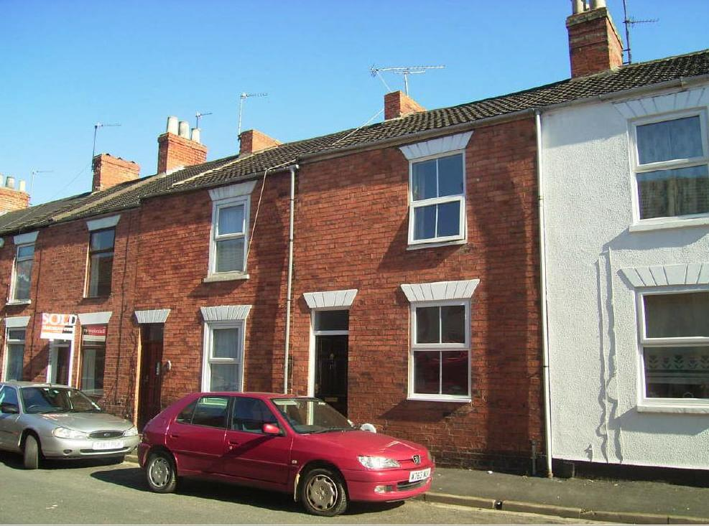
I am a 3 bedroom terraced property in good condition throughout and have a lounge and dining room, gas fired heating and full double glazing. I am situated on Dudley Road in Grantham.
PLEASE STATE YOUR VALUATION £
Good luck.

