Computing – Fake Images
Photo editing software is often used to create fun, interesting images that you wouldn’t normally get to see. Sometimes, people edit photos to try and make the ‘perfect’ image.
Look at these images for example, same person, but one image has been heavily edited. Can you spot what has been edited?
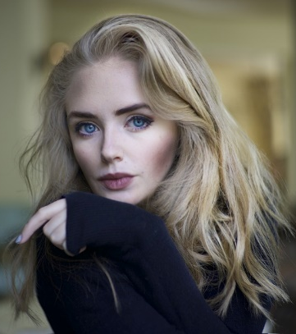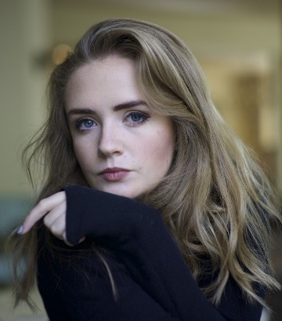

It’s important that you can spot these fake images, because you don’t want to compare yourself to a ‘perfect’ image.
Complete this table.
Reasons why people edit images. | Reasons why you should not edit images of yourself.

